# Lab 03B: Granting Administrator Access

**Lab Overview:** Time to give away the keys to the kingdom. In this lab you will learn how to make someone a farm administrator and what rights that gives them. Then you will grant access to the SSP and the different options available there, including how to disable My Sites in your farm.

## Exercise 1: Granting farm administrator access

1. Open up **Central Administration**
2. Click the **Operations Tab**
3. Under Security Configuration click **Update farm administrator’s group**
4. Click **New > Add Users**
5. For username enter **TPG\Bob**
6. Deselect **Send welcome e-mail to the new users**
7. Click **OK**
8. Now Bob Farmer has Farm Admin access log in as him and see what options he has available.
   1. In the top right corner click on **Welcome SharePoint Setup Account**
   2. Click **sign in as Different User**
   3. Username **tpg\bob**
   4. Password **pass@word1**
   5. Click **OK**

If you start clicking around you will see Bob has access to Central Admin now. But because he is not a local administrator on the server he does not have access to:

* Operations > Services on Server
* Operations > Incoming e-mail settings
* Applications > Create or extend Web application
* STSADM.exe

1. Still logged in as Bob click on **Primary SSP** on the quick launch bar.
2. Enter **tpg\bob** and **pass@word1** and click **OK**
3. Error: Access Denied – This is because SharePoint does a good job of security isolation.

Exercise 2: Grant access to the SSP

Because Bob is a farm admin he could give himself access to the SSP but that isn’t what we want. Instead log back in as SP_Admin and take a look at how to grant access to the SSP.

1. Log in as SP_Admin
   1. Click **Sign in as a different user**
   2. Username **tpg\sp_admin**
   3. Password **pass@word1**
   4. Click **OK**
2. Add Bob to the SSP Site Collection as a viewer
   1. Click Site Actions > **Site Settings**
   2. Under Users and Permissions click **People and groups**
   3. Click **New**
   4. For users/groups: enter **tpg\bob**
   5. Deselect **Send Welcome email** and click **OK**
   6. Click **Shared Services Administration: Primary SSP** in the breadcrumb to return to the home page.

Now Bob can log into the SSP and manage search settings, the Excel Service Settings (if you have Enterprise edition), and can view the various links list. But there is still a lot of stuff Bob cannot do. What is even stranger? Bob can now give himself the additional permissions he wants

1. Give Bob more permissions
   1. Under User Profiles and My Sites click **Personalization services permissions**
   2. Click **Add Users/Groups**
   3. For Users/Groups: enter **tpg\bob**
   4. **Select all of the boxes** and click **Save**

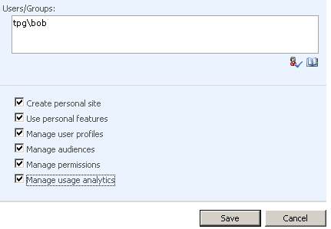

1. What are all of these different permissions? Glad you asked.
   1. **Create personal site** gives the user the capability to create and use a My Site. Going deep here will have to be saved for another day but if you want to make that My Site link disappear take away this right from the users. But you didn't give it to them. Why do they have it? Go back to the manage permission screen. All authenticated users were given this right by default.
   2. **Use personal features** is another topic for another day. Essentially though this provides the My Links functionality and allows users to manage their Colleagues.
   3. **Manage user profiles** this allows your user to do just that. Get in there and modify the profiles for this SSP. Give them this right and now they can access the links: User profiles and properties, Profile services policies, and My Site Settings.
   4. **Manage audiences** you guessed it but now you can click that handy little Audiences link. Once you are there you can set the schedule or define the rules for building those global audiences.
   5. **Manage permissions** this will let that user modify Personalization services permissions (the stuff we are doing right now).
   6. **Manage usage analytics** this gives the user access to make changes to Usage reporting. Small bug here but if the user doesn't have this right they can still open up the screen. Then if they make a change and hit ok they get a 403 forbidden error.

So now if you have given the user all of those permissions they should be a happy camper? Depends. If you have MOSS Enterprise (which in the lab you do) then one more thing to do.

1. Giving Bob control of the BDC.
   1. Click **Shared Services Administration: Primary SSP** from the breadcrumb
   2. Under Business Data Catalog click **Business Data Catalog permissions**
   3. Click **Add Users/Groups**
   4. Enter **tpg\bob**
   5. **Select all permissions** and click **Save**

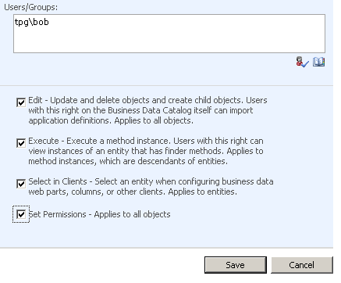

Now Bob can do everything in the SSP.

Exercise 3: Disable My Sites for all users

My Sites are personal sites that users are automatically created the first time a user click the My Site link at the top of the page. They are a great tool for expanding social networks internally, allowing users to easily share information, and for allowing them to have a private SharePoint site. My Sites are very powerful and with power comes risk. For most corporations they should not be implemented without a carefully thought out strategy. By default they are enable. When you first setup a farm if you have not planned for My Sites the recommendation is to disable them until you are ready.

1. Disable My Sites for all authenticated users
   1. Return to the home page of the SSP by clicking **Primary SSP** in the breadcrumb.
   2. Under User Profiles and My Sites click **Personalization services permissions**
   3. Under User/Group Name click on **NT Authority\Authenticated Users**
   4. Deselect **Create personal site** and click **Save**

Now you will notice that Bob and SP_Admin still have My Site links. That is because you have given them that right individually. You could simple remove it for them if you wanted to make sure they didn’t use My Sites. You can leave the permission for now. In Module 8 you will learn more about My Sites and then re-enable them.

Pop Quiz Time

Take a look at the screen shot below. Can you explain why each account was automatically assigned permissions to the SSP?

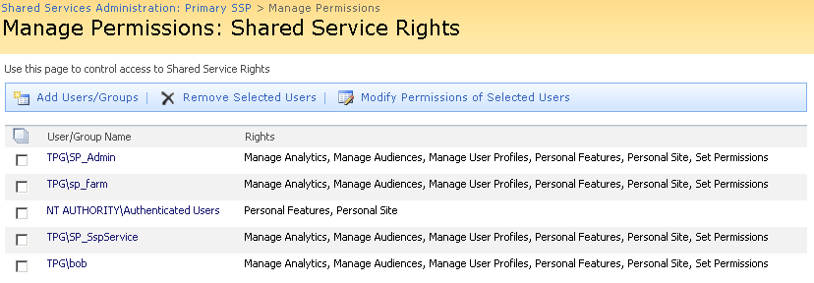

**End of Lab**